Chosen proposal



ABETHU SPHELELE NDEBELE
ST 10533948
GR 4
WEB DEVELOPMENT

TABLE OF CONTET

1. Organization overview

2.Website goals and objectives

3.Current website analysis

4. Proposed website features and functionality

5.Design and user experience

6.Technical Requirements

7.Timeline and milestones

8.Budget

9.References

PROPOSAL

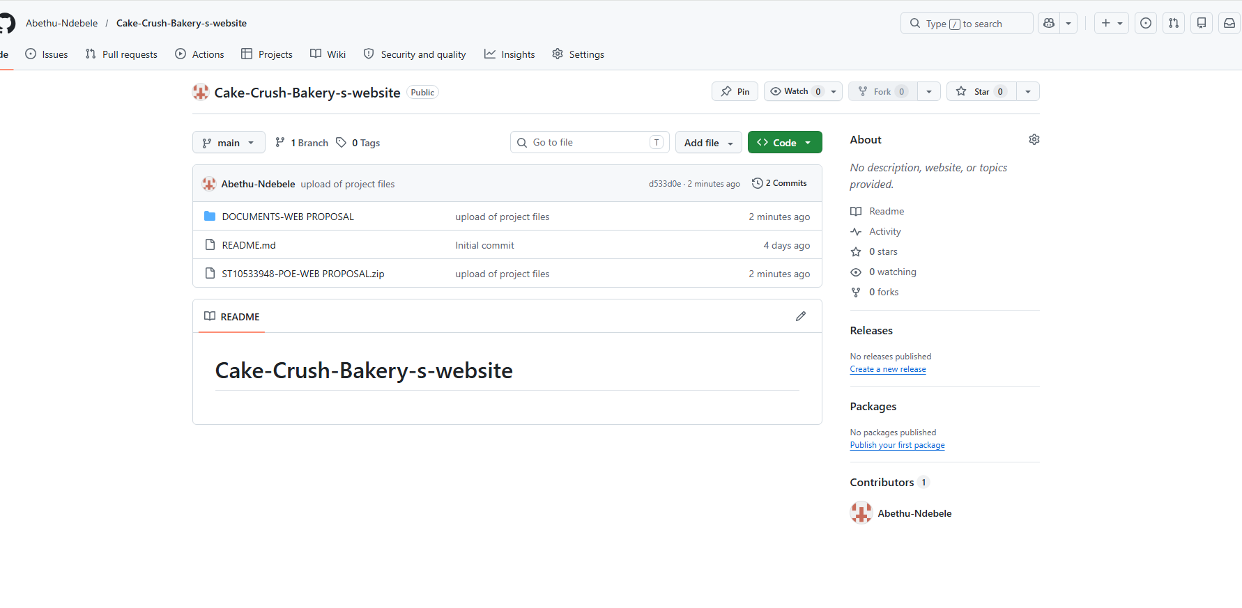
Github screenshot and github link below:
https://github.com/Abethu-Ndebele/Cake-Crush-Bakery-s-website.git
1.ORGANISATION OVERVIEW
NAME: CAKE CRUSH BAKERY
Background:
- Cake Crush Bakery began as a small dream rooted in the love of baking. From humble beginnings in a kitchen where each recipe was perfected in every way one can think of. This was the place where we crushed crumbs not aspirations, a place where each cup crafted a moment. The bakery aims to give high quality, affordable baked goods and most importantly bring smiles to people’s faces.
- MISSION:
Making sure we deliver freshly baked goods that bring smiles to people’s faces
- VISSION:
Becoming the most recommended bakery shop known for its quality goods that meets the needs of the customers
- TARGET AUDIENCE:
1.Families
2.Local residence that will need freshly baked cakes and bread almost every day or Maby casual cakes and treats
3.Event and occasion buyers that are planning events that will need cakes and treats for weddings, birthdays and other relevant events that will need the goods
4.Companies that plan events that will need catering for the day
5.Online customers that are looking for convenient ordering
2.WEBSITE GOALS AND OBJECTIVES
Goals for the website:
- to increase our online visibility to ensure that our customers can easily access our products. this will help us to showcase our amazing work, reviews and updates Maby about prices and other relevant information
Objectives:
- Enabling online ordering system that will help us reach our customers that are not able to place their orders due to certain reasons.
- Enabling us upload our latest catalogues and lates products that we produce
Key performance indicators
- Number of orders received online
- Number of people visiting my website
- Customers that inquire via the contact form and also social engagement
3.CURRENT WEBSITE ANALYSIS

- Cake Crush Bakery doesn’t have a website
- Strengths: Strong customer base
- Weakness: it does not have any online ordering system
- Improvements: creation of a very formal website.
4.PROPOSED WEBSITE FEATURES AND FUNCTIONALITY

PAGES:
1 Homepage: overview of services
2 About us: This is where our background info will be displayed
3 Products: Goods sold
4 Cart: where you will be placing your orders
5 Contact: business details
5.DESIGN AND USER EXPERIENCE
Color scheme: warm bakery theme colors
Typography
- Heading Aptos font in size 11
- Body: a well-organized font that is easy to read
Layout and design:
- Our layouts and designs are neat, ensuring visibility to people it has a easy navigation menu and highlights the featured products
User Experience Considerations
- Simpler navigation bar
- Pages that load fast
- Visible product categories
6.HOSTING AND DOMAIN
Hosting: reliability
Domain: brand relevance
Technologies:
Java
Html
CSS
7.TIMELINE AND MILESTONES
PHASE | TASK | DURATION
Week1 | planning | 1week
Week2 | designing | 1week
Week3-4 | development | 2weeks
Week5 | testing | 5days
Week6 | submission | 1week
8.BUGDET
Item | Estimated cost
Hostname  Design  Maintenance  Hosting | R 150p.a  R 2000p.a  R 350p.a  R 1000p.a

Estimated total=R3500
9

References

- Barnes,J.,2020.Web Design for Beginners: A practical Guide .2nd ed. London: Routledge.
- Chaffey,D.and Ellis-Cadwick,F.,2022.Digital Marketing:Strategy,implemented and practice .8th ed.Harlow:Pearson Education
- Jones, L., 2021. ‘Best practices for bakery websites’. Bakery Business Online. Available at: https://www.bakerybusiness.com/articles/best-practices-bakery-websites⁠� [Accessed 31 March 2026].
- Smith, R., 2018. HTML, CSS and JavaScript for Web Developers. 3rd ed. New York: O’Reilly Media.

- WordPress, 2026. WordPress.com: Online store setup guide. Available at: https://wordpress.com/learn/online-store-setup⁠� [Accessed 31 March 2026].
Shopify, 2026. Shopify for Small Businesses: Building an Online Bakery. Available at: https://www.shopify.com/guides/bakery-online⁠� [Accessed 31 March 2026

